2200032991
CTS-WEEK-5
MICROSERVICES
Creating Microservices for account and loan
https://start.spring.io/
use this link to create your zip files as loan and account
by giving the following data as such
and even select your dependencies SPRING BOOT DEV TOOLS , SPRING WEB
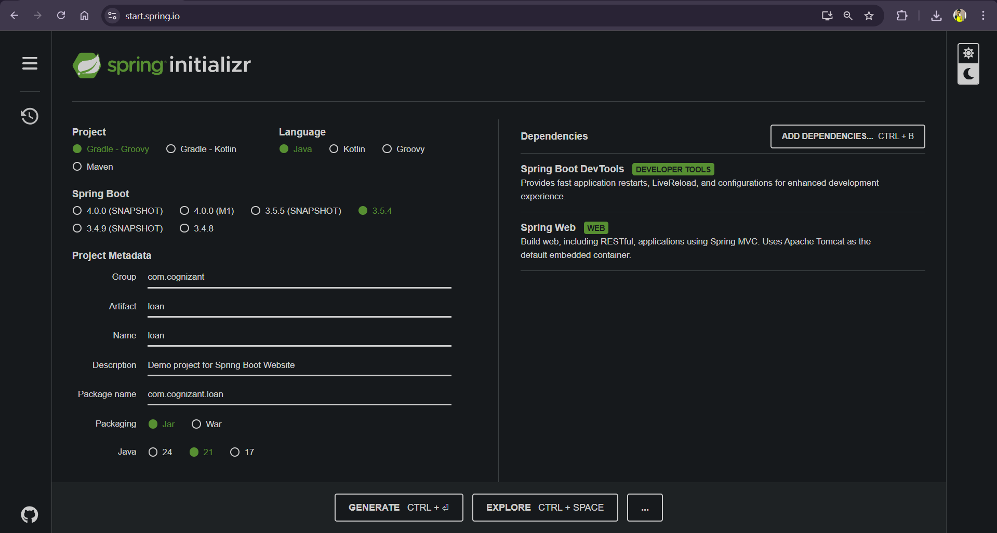
and then click on generate you will get your two files
now make a path in your folder
D:\Koushik\CTS WEEK-5\Microservices_with_API_Gateway\Creating Microservices for account and loan\2200032991\microservices
or what ever name you give
the two zip files which you get extract them and paste the in the above foaled location
next
create a controller foalder in the both account and loan as the paths below
1. D:\Koushik\CTS WEEK-5\Microservices_with_API_Gateway\Creating Microservices for account and loan\2200032991\microservices\account\src\main\java\com\cognizant\account\controller
2. D:\Koushik\CTS WEEK-5\Microservices_with_API_Gateway\Creating Microservices for account and loan\2200032991\microservices\loan\src\main\java\com\cognizant\loan\controller
Now create your controller.java files
Make sure that both the accounts and loan have pom.xml files in them
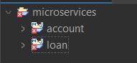

you will get to see your output for accounts in this link
http://localhost:8081/accounts/1234
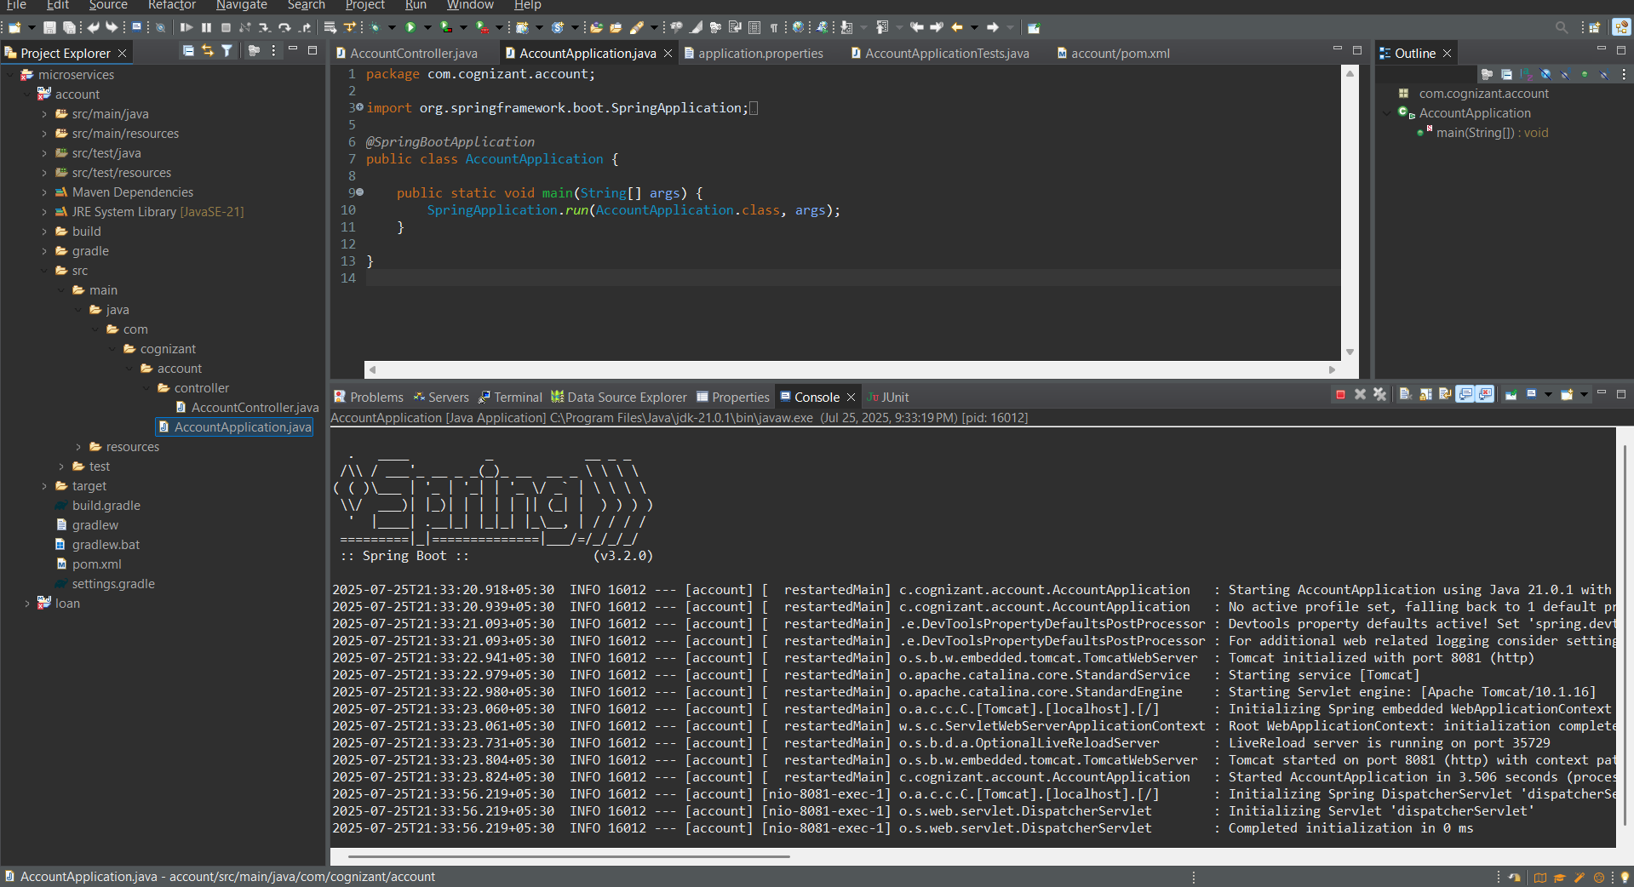
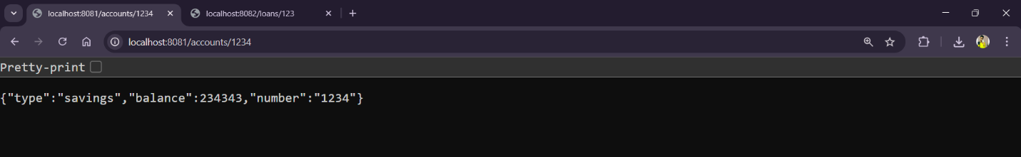
and for loans in this link
http://localhost:8082/loans/123
